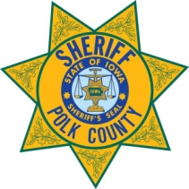**Polk County Sheriff’s Office Sheriff Kevin J. Schneider**

Polk County Sheriff’s Office Headquarters Phone (515) 286-3814

5995 NE 14th Street Fax (515) 875-5579

Des Moines, Iowa 50313-2517 [www.polkcountyiowa.gov/sheriff](http://www.polkcountyiowa.gov/sheriff)

January 7, 2025

To Whom It May Concern:

The Polk County Sheriff’s Office is supportive of the SAFE Center of Iowa and its efforts to secure funding to establish free-standing sexual assault clinics in our state. As envisioned by SAFE Center of Iowa, each regional clinic will be staffed by Sexual Assault Nurse Examiner (SANE) Nurses and will provide access to a wide variety of wrap-around services, such as infectious disease prevention and treatment, sexual assault advocacy, counseling services, law enforcement support, and legal system navigation.

This model has proven to be successful and has led to dramatically improved patient and public health outcomes in other states.

The stated goal of the SAFE Center of Iowa is to start with a primary SAFE Center clinic in the Des Moines Metro and then expand throughout Iowa, ultimately to offer immediate care to victims, with the option of follow-up appointment.

From a law enforcement perspective, this will benefit victims, as well as law enforcement agencies, in that the sexual assault kits can be relied upon to be collected appropriately by trained professionals and will help in successful investigations.

I believe the SAFE Center of Iowa and its plan to be in the best interests of all Iowans and support its efforts moving forward.

Thank you for your consideration.

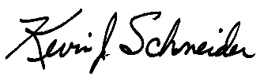

Kevin J. Schneider

Polk County Sheriff