August 16th, 2022

Governor Reynolds,

Hello. My name is Jason Hatcher, and I am a Detective with the City of West Des Moines Police Department and have been for over twenty-three (23) years. I am currently assigned to the Criminal Investigations Unit (CIU), and my main focus of Investigations are Crimes Against Persons, specifically Sexual Assault and Domestic Violence Investigations.

Over the course of the last seven (7) years, I have found that my case load is almost doubling with the number of Sexual Assaults being reported. Victims of these criminal acts include adults and children. I work directly with the Sexual Assault Response Team (S.A.R.T.) in the Des Moines Metro area and I have found that all members are vital to my investigations.

I want to point out that a sexual assault investigation often takes weeks and/or months to investigate and I have found that the Des Moines Metro area needs to improve where the victims can go and/or turn to in order to make the process easier and more comfortable. I believe that by creating a center for Survivors and their Families would allow them to feel more comfortable and make things a little easier on them, as the process is long. Also, by having a center large enough to support nurses, counselors, advocates and having rooms where interviews can take place, would ‘ease the fear’ for the Survivors. It would allow these investigations to take place in one area and the corroboration between everyone working for the Survivor would be easier and more sustainable.

Please consider creating a ‘safe place’ such as Sexual Assault Center in the Des Moines Metro. It’s about time we create a calming and safe place for the Survivors, as the numbers will only continue to grow.

Thank-You for your time,

Detective Jason Hatcher #170

Office: 515 222-3316

Cell: 515 208-5090

Fax: 515 222-3331

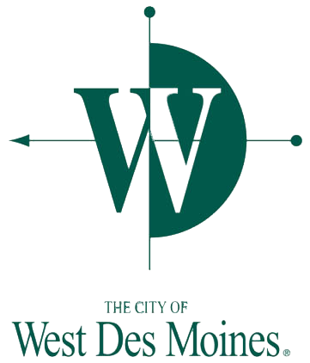

Police Department

250 Mills Civic Pkwy  
P.O. Box 65320  
West Des Moines, IA 50265-0320

Emergency  
9-1-1  
  
24 Hour Dispatch Center  
515-222-3321  
  
Support Services Division  
Information/Records  
515-222-3320  
  
Chief’s Office  
515-222-3300  
  
Community Education & Outreach  
515-222-3389  
  
Patrol Division  
515-222-3394  
  
FAX 515-222-3331  
  
Email: police@wdm.iowa.gov

www.wdm.iowa.gov



Commission on Accreditation for Law Enforcement Agencies