January 7,2025 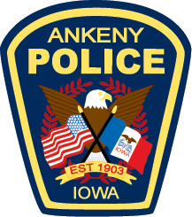

To Whom It May Concern,

My name is Darius Potts, and I am the Chief of Police for the Ankeny Police Department. I am writing to express the full support of the Ankeny Police Department for the SAFE Center of Iowa.

During my previous law enforcement experience with the Phoenix Police Department, I had the privilege of working in a jurisdiction with a similar facility. This experience gave me firsthand insight into the immense benefits such a center provides to both victims and law enforcement.

Facilities like the SAFE Center play a vital role in reducing the already traumatizing experience for victims of crime, offering a compassionate and supportive environment. By consolidating critical services in a single location, these centers streamline the investigative process and provide victims with access to necessary resources in a setting designed to prioritize their well-being.

For our detectives, the SAFE Center represents a significant advantage—a "one-stop shop" that enhances efficiency while ensuring thorough investigations. This approach not only aids in building stronger cases but also allows officers to focus on their primary responsibility: seeking justice for victims.

The Ankeny Police Department recognizes the critical need for a facility like the SAFE Center in our community. Its presence would strengthen our collective efforts to serve and protect while fostering trust and healing for those impacted by crime.

Thank you for your dedication to this essential initiative. Please do not hesitate to reach out if I can provide further information or assistance.

Sincerely,  
Darius Potts  
Chief of Police  
Ankeny Police Department